**A Review of Imports Structure and Reforms in Ghana**

**Nomfundo Portia Vacu[1], Nicholas M. Odhiambo[2]**

*Department of Economics, University of South Africa, UNISA, South Africa, n.vacu@yahoo.com*

2 *Department of Economics, University of South Africa, UNISA, South Africa, odhianm@unisa.ac.za*

**Abstract:** The main aim of this study is to provide an overview of the structure and performance of Ghana’s imports. Specifically, to take into account the effects of the country’s historical trade policy reforms and other determinants during the period 1995-2014. The findings show that, over this period, the country successfully established a few bilateral trade agreements with African and non-African countries. A larger share of Ghana’s imports originate from developed countries. The results also that the leading import sources for Ghana at a continental level include Europe, Asia, and Africa. In Africa, Nigeria is the main source of Ghana’s imports. Ghana’s imports are dominated by manufactured goods. The analysis suggests that Ghana’s imports demand are sensitive to changes in factors, such as trade openness, economic growth, and the exchange rate.

**Keywords:** *Ghana, imports, trade policy reforms*

**JEL Classification:** F130

1. **Introduction**

Trade is considered to be an important feature of economic growth, especially in developing countries. It benefits countries in many ways, such as boosting the country’s economic performance, and integrating it into the global economic environment. Since Ghana’s accession to democracy in 1957, trade has been one of the most significant factors in the country’s economy. For example, in 1960, trade accounted for 63.6% and this increased to 88.5% in 2014 (World Bank, 2014). This was accompanied by an increase in the country’s economic growth, as measured through real gross domestic product (real GDP), from R5.2 billion in 1960 to R33.5 billion in 2014 (see World Bank, 2014). Over this period, imports accounted for a significant share of economic growth, ranging between 35.4% and 50% (see UNCTADSTAT, 2014). This is also accounted for by an increase in the country’s reliance on imports for domestic consumption. As measured through the imports penetration ratio, over the period 1995 to 2014, there has been a general increase with a few declines in between in the share of Ghana’s domestic consumption that is catered for by imports. Notably, in 2011, 2012 and 2013, imports accounted for more than 50% of Ghana’s domestic consumption (see UNCTADSTAT, 2014).

The effectiveness of trade in Ghana has been strengthened by trade policy reforms. Since independence in 1957, the country has experienced two trade and repayment policy reforms, which are identified as Ghana’s trade cycles (see Harvey and Sedegah, 2011). These cycles encompassed trade liberalisation at different levels. For example, the first phase started from 1950 to 1971 with the liberal trade regime, introduction of controlled regime, breakdown of control system, attempted liberalisation and import liberalisation. This was followed by the second phase, which started in 1972 and still continues.

The second cycle continued with the implementation of the phases that were introduced in the first cycle. Phase one and two in both cycles can be classified as controlled trade regimes, while phase three, four and five are categorised as liberal trade regimes (see Harvey and Sedegah, 2011). These phases focus more on opening up the economy, which has encouraged the country to import foreign products and services, so as to meet domestic demand.

Although previous studies such as Abayie and Nkruma (2009); Oesi (2014) have looked at Ghana’s import demand function, to our knowledge there is no recent study that provides a thorough analysis of the variations in import demand covering the period from 1995 to 2014. This paper therefore provides a summary of Ghana’s import demand by addressing the question of how the country’s imports are structured, as well as the performance of imports, taking into account the effect of historical and current trade policy reforms and the impact of other factors over the period 2014. The rest of the paper is divided into four sections. Section 2 gives a brief overview of Ghana’s historical and current trade policy reforms, focusing mainly on the imports side of trade. Section 3 and 4 covers the structure and trends of imports over the period 1995 to 2014. Section 5 looks at factors affecting imports demand in Ghana, while section 6 concludes the study.

1. **Trade Policy Reforms in Ghana Before and Since 1957**

The first cycle of Ghana’s trade reforms was concurrent with the country’s movement towards independence in 1957. Before this period, the country was a member of the sterling zone in which no restrictions were imposed on member countries and import restrictions were only on certain non-durable goods from non-member countries. After independence, Ghana’s general economic policies required massive government involvement in the economy, with relevant and sector specific controls and restrictions (see Laryea and Akuoni, 2012). This included industrialisation, which was pursued through a number of development strategies and policies, such as the import substitution policy. The import substitution policy was adopted to encourage domestic production of final goods. Concurrent with the attainment of independence in 1957, Ghana joined the General Agreement Tariffs and Trade (GATT) (see WTO, 2007). Between 1957 and 1961, the country had to invest more on domestic industrialisation. This resulted in an increase in total government expenditure, which was accounted for largely by capital expenditure, and led to a drastic increase in budget deficit and demand for imports. Due to the increase in imports, the current account deficit almost doubled in 1961 (see Steel, 1972). As a result, the first trade regime only lasted until 1967 (see Brafu-Insaidoo, 2008).

Between 1972 and 1982, the Ghanaian government had to impose restrictions on imports in an effort to improve the position of its balance of payment. This included tariffs and imports licencing. Over the same period, the country revised its currency by 26%. This period was also characterised by a wide variation of import duties and taxes aimed at revenue generation. By 1982, the volume of imports and government revenue had gone down, and the country was faced with deteriorating economic performance and foreign exchange rate constraints. In response to this, the country resorted to trade reforms characterised by the replacement of quantitative restrictions with price instruments, and the creation of a liberal regime (see Brafu-Insaidoo, 2008; Harvey and Sedegah, 2011).

The period after 1983 was marked by a trade liberalisation under economic recovery and structural adjustment programme (ERP and SAP). This included tariff adjustment, import liberalisation, foreign exchange liberalisation, deregulation, and institutional reforms that effected customs, exercise, and preventive service (see Laryea and Akuoni, 2012). Brafu-Insaidoo (2008) categorised these trade reforms into three phases, namely, the period of attempted liberalisation, the period of import liberalisation, and the period of trade liberalisation regime. The main aim of these reforms was to encourage exports and to improve exchange controls (see Republic of Ghana, 1983, cited in Laryea and Akuoni, 2012). According to Brafu-Insaidoo (2008), the phase of attempted import liberalisation lasted over the period 1983 to 1986. During this period, a system of bonuses and surcharges was introduced, which led to an increase in actual exchange rate. Before 1983, the country had three tariff schedules, which were high at 35 %, 60%, and 100%. In 1983, these schedules were reduced to 10%, 20%, and 25% respectively (see Ocran, 2006). Over the same period, the number of restricted imports was reduced. The year1986, in particular, was marked by the redefinition of import licence categories with the introduction of a new exchange rate system, reduction of import tax schedule, and reduction of sale taxes on imported goods by 10% (see Brafu-Insaidoo, 2008; Harvey and Sedegah, 2011).

The period between 1987 and 1991 was marked by changes in Ghana’s tariff structures. During this period, import licencing was completely abolished. As a result, the cost of importing in Ghana went down by a range of 5 % to 10% points in all commodity groups, except for luxury goods (see Jebuniet al, 1994). Import tax rates on raw material and capital goods were reduced by 5% points. This period was also marked by the establishment of the Economic Community of West African State (ECOWAS) scheme, and Ghana, as a member of the ECOWAS, was affected by the rules emanating from that scheme (see also Harvey and Sedegah, 2011; ECOWAS commission, 2012; Brafu-Insaidoo, 2008; Ocran and Adjasi, 2009).

Between 1992 and 1999, Ghana reduced its preferential tariffs of 20% on imports from a few selected countries that had been granted the ECOWAS status (see Bhasin, 2011). The preferential treatment rates that the country charged on imports from ECOWAS member countries ranged between 8% and 20%, while rates on imports from non-member countries ranged between 10% and 25% (see Brafu-Insaidoo, 2008). By this period, the simple average import tariff was 17%, and the highest duty rate levied on consumer goods was 25%. Also, most imports from member countries attracted duty free rates, which included a range of unprocessed agricultural goods. During this period, 10% duties were imposed on selected zero-rated and exempted goods regarded as non-essential. This was used to stimulate government tax revenue (see Laryea and Akuoni, 2012; Brafu-Insaidoo, 2008). By this period, Ghana had a simple tariff structure, where primary products, capital goods, and some basic consumer goods were charged a 0% rate, while raw material, some basic consumer goods, and intermediate goods were charged 10%. Lastly, a rate of 25% was charged mostly on final consumer goods. During the same period, Ghana became a founding member of the World Trade Organisation, and signed an agreement with the United States of America (see also Laryea and Akuoni, 2012; WTO, 2007).

The period 2000 to 2012 was marked by a number of structural adjustments in Ghana’s import tariffs. By January 2000, the simple average tariffs had decreased to 13%, while high duty rate applied on consumer good had decreased to 20%. However, in February 2000, tariffs increased to 14.7%, and a special import tax of 20% was re-introduced on 7% of the tariff line. As a result of this, tariffs applied on mostly consumer goods increased to 40%. Ghana's tariff structure, with rates of 5%, 10%, 20%, and now 40% (with the special import tax), had “built-in” tariff escalation within certain manufacturing groups, especially textiles, leather, chemicals, basic metals, food, beverages, and tobacco. During the same period, non-tariff barriers applied on imported motor vehicles older than ten years were removed (see WTO, 2001). In 2005, the country launched the Trade Sector Programme (TSSP). In terms of imports, this programme was aimed at establishing effective rates of protection methodology (USAID, 2006). This period was also marked by the establishment and full adoption of the ECOWAS Common External Tariff.

Between 1957 and 2012, Ghana became a member of a number of international groups. For example, the country is a member of the World Trade Organisation, Economic community of West African States (ECOWAS), and African Union. Within these groups, Ghana has signed bilateral agreements with individual countries. As a member of the ECOWAS, Ghana signed the Economic Partnership Agreement (EPA) with the European Union member countries. This agreement was initialised in December 2007 and signed in October 2014. It was designed as a tool for development and regional integration.

* 1. **Tariffs of Ghana**

Trade policy developments in Ghana involved mostly removal and adjustment of trade tariffs. The country has been successful in binding its import tariffs, and has made significant progress in opening its economy through tariff removal and reduction. In terms of final bound duties, by 2014 the average binding coverage was above 90% for most of the product lines, with the exception of minerals and metals, wood and paper, textile, non-electrical products, and transport products lines (WTO, 2014). Also, with the exception of a few product groups, the country had 100% tariff lines bound and a maximum of 99 ad-varolem duties applied by 2014 (WTO, 2014). In terms of the MFN applied duties, the maximum applied was 20% for all product lines. Notably, product lines with the highest share of imports that are free of MFN applied duties include non-electrical products, transport, and petroleum, with 76%, 47%, and 36% of their product lines, respectively. A larger share (more than half) of agricultural, petroleum, wood, and paper import products were MFN duty-free by 2014 (WTO, 2014).

1. **Ghana’s Major Import Sources in the World**

**3.1. Ghana’s Top Five Import Sources in the World**

Ghana trades with both developing and developed countries in the world. The majority of its imports are from developed countries. The top 5 import sources for the country include Germany, United States, United Kingdom, Nigeria, and China. Figure 1 presents the composition of imports by major import sources over the period 1995 to 2014.

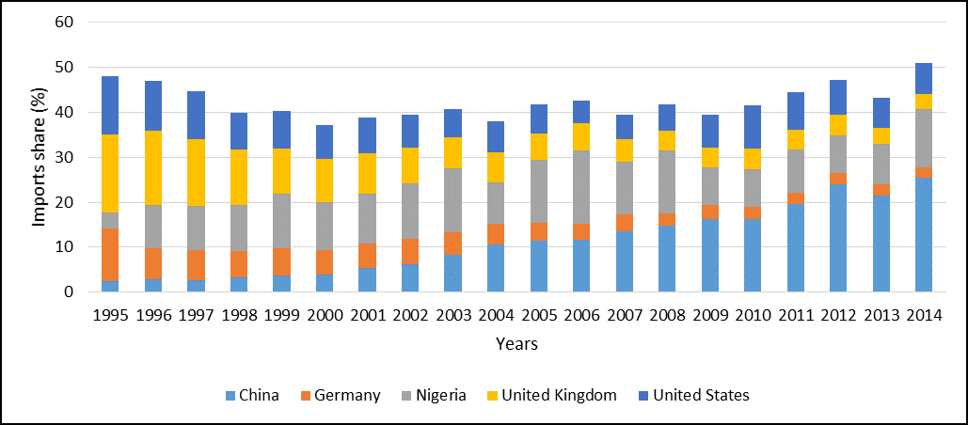

**Figure 1: Share of Ghana’s imports by major imports source (1995-2014)**

*Source: UNCTADSTRAT, 2014*

On average, China and Nigeria appear to be the leading import sources for Ghana. For example, they contribute 26% and 25% respectively, followed by the United States (19%) and the United Kingdom (19%). The lowest contributor in the top 5 is Germany with 11% (UNCTADSTRAT, 2014). During the period 1995 to 2000, China’s contribution towards Ghana’s imports was low compared to other major exporters to Ghana. However, this changed in 2001 when its contribution started to be highly significant, while the contribution from other major sources started declining slowly. The period from 2001 onwards was marked by a series of tariff adjustments which made importing cheaper for Ghana. The low proportion of Germany’s exports to Ghana can be explained by the adjustments that have taken place in the trade relations between the two countries. This includes the abrogation of the trade agreement between the two countries, and as a result of these adjustments, the share of Germany’s imports has been decreasing over the years (see Figure 1).

At continental level, a larger share of Ghana’s imports originate from Asian, European, and African countries (see UNCTADSTRAT, 2014). Between 1995 and 2006, Europe was the largest import origin for Ghana, with its share decreasing over the years from 47% in 1995 to 24% in 2014. In 2006, Europe was overtaken by Asia, which accounted for the larger share from 2006 to 2014. Imports from American countries had also been decreasing over the years, falling from 18% in 1995 to 11% in 2014 (see UNCTADSTRAT, 2014). The decline in imports from Europe can be attributed to the trade policy adjustments that took place between Ghana and Germany over the same period.

* 1. **Ghana’s Import Relations with the European Union**

The European Union (EU) is one of the major trade partners with Ghana, and Ghana has a bilateral trade agreement with its member countries. It is therefore necessary to look into the nature of this partnership and the impact that it has had on Ghana’s imports by observing trends of imports originating from the EU over the specified period. Figure 2 presents Ghana’s performance in terms of trade with the EU.

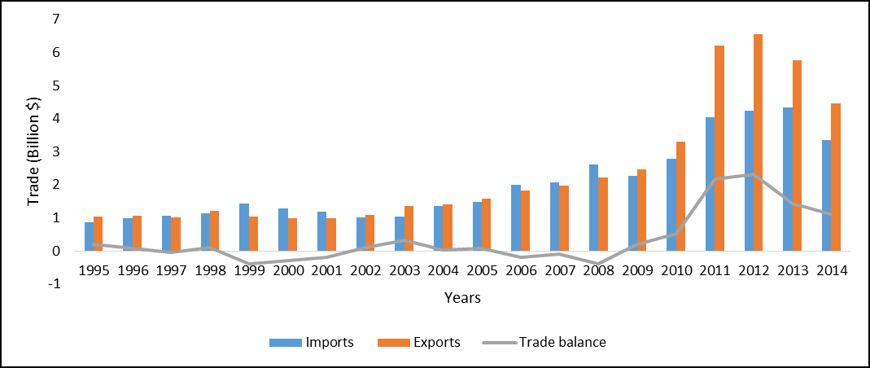

**Figure 2: Ghana’s trade balance with the EU (1995-2014)**

*Source: UNCTADSTRAT, 2014*

Over the period 1995 to 2007, Ghana had been a net importer, as it was importing from the EU more than it was exporting. However, this changed in 2008 as the country started recording a trade surplus. The surplus only went up between 2008 and 2011; beyond this period it had been declining. The period 2008 to 2014 is the period when the initiation and signing of the agreement between Ghana and the EU took place. Over the period 1995 to 2014, EU’s exports to Ghana followed a similar pattern as Ghana’s imports from the world over the same period. The list of the top 10 is dominated by manufactured products. For example, the petroleum oils or bituminous minerals containing by weight more than 70% of oil accounted for 11% of Ghana’s total merchandise imports from the EU, followed by motor vehicles for the transport of persons (6%), and motor vehicle for transport of goods and special purpose (5%).

* 1. **Ghana’s Import Relations with Africa**

Ghana is located in the African continent, and within the continent, the country trades with some of the African countries. Figure 3 illustrates Ghana’s trade and trade balance with African countries.

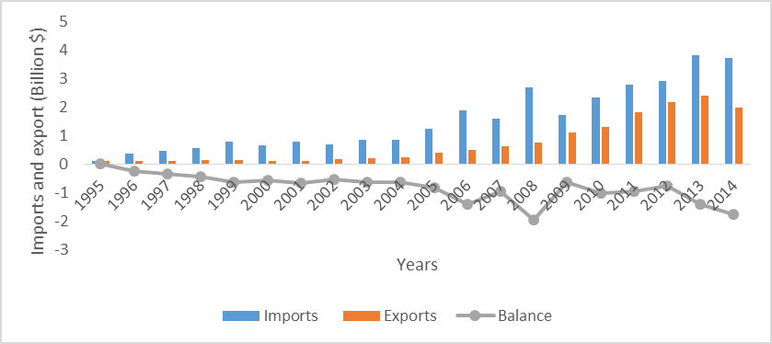

**Figure 3: Ghana’s merchandise trade and trade balance with the African continent (1995-2014)**

*Source: UNCTADSTRAT, 2014*

Over the period 1995 to 2014, the country was importing (from) more than it was exporting to African countries. In other words, the country had been recording a negative trade balance over the years. However, it is also worth noting that the quantity of imports and exports moving between Ghana and other African countries has been increasing over the years. This is a sign of improving trade relations within the African continent. In 2002, the country experienced a sharp increase in its imports from African countries. This can be attributed to the adjustment of trade policies, especially trade protection policies that were introduced during the period between 2000 and 2012.

Ghana has been contributing towards the total imports that the African continent imports from the world, and the country’s imports had generally following similar pattern as Africa’s imports over the years from 1995 to 2011. However, in 2012, Ghana’s imports started decreasing, whilst Africa’s imports were increasing (see UNCTADSTRAT, 2014*).* Over the period under review, Africa’s contribution to Ghana’s imports from the world fluctuated between 1.7% and 2.3 % (see UNCTADSTRAT 2014*)*. This is less significant and is an indication that there is a need to establish strong trade relations amongst African countries.

In Ghana, petroleum oils account for a large percentage of imports from Africa. Over the period 1995 to 2014, these products accounted for an annual average of 46.6% of Ghana’s total imported products from Africa, which is close to 50%. Over the reviewed period, petroleum oils accounted for between 28% and 59% (see UNCTADSTRAT, 2014). In terms of African import sources, the country’s imports originate mainly from Nigeria (50%), South Africa (15%), Cote d’Ivoire (18%), Togo (4%), and Morocco (2%), based on annual average (see UNCTADSTRAT, 2014). Nigeria appears to be the main African import source for Ghana over the period1995 to 2014. This is not surprising given that Nigeria is the main African import source for most African developing countries. Also, Ghana has some form of specific trade relations with Nigeria. Ghana does not trade much with most of the African regions. Most of the country’s imports from Africa originate from Western African countries. The largest amount of these imports is accounted for by Nigeria (50%) (see UNCTADSTRAT, 2014).

* 1. **Ghana’s Imports Relations with the Economic Community of West African States (ECOWAS)**

Ghana forms part of the Economic Community of West African States (ECOWAS). Over the period 1995 to 2014, the country was one of the lowest importing countries in the ECOWAS region, relative to its counterparts (see UNCTADSTRAT, 2014). For example, Ghana accounted for an annual average of 0.05%, following Gambia (0.02%) and Cabo Verde (0.01%). Within the ECOWAS, the country trades with some of the countries. Figure 4 shows trends of trade between Ghana and ECOWAS member countries (see UNCTADSTRAT, 2014).

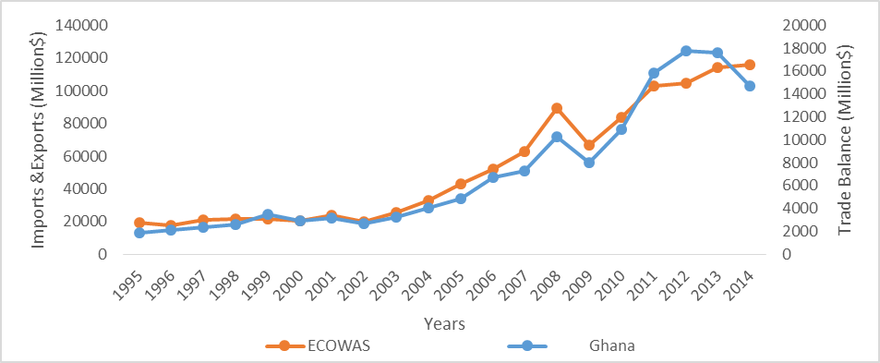

**Figure 4: Ghana’s merchandise imports from the ECOWAS (1995-2014)**

*Source; UNCTADSTAT, 2014*

Over the period 1995-2014, the country was a net importer with the ECOWAS member states as it had been recording a deficit. The trade gap (deficit) for Ghana had been widening over the years even though exports had been increasing, but imports had been increasing even faster. Ghana’s total imports from the world follow similar trends as the ECOWAS’s total imports (see UNCTADSTRAT, 2014).

A large portion of Ghana’s imports from the ECOWAS are from Nigeria and Côte d'Ivoire. Over the period 1995 to 2014, their merchandise exports to Ghana amounted to an annual average of $760.1 million and $ 286.6 million, which is 65.3% and 24.6% of the ECOWAS’s merchandise exports to Ghana, respectively (see UNCTADSTRAT, 2014).

Of the top 10 of Ghana’s merchandise imports from the ECOWAS region, petroleum oils, oils from bitumen, materials, crude remains the main import product for Ghana and accounts for 57% of Ghana’s imports. The country’s imports from ECOWAS are dominated by manufactured goods.

1. **Structure and Performance of Ghana’s Imports**

Ghana is known for its high dependence on imports for domestic consumption since gaining independence in 1957. The country ranked 78 in terms of imports in the world in 2013 and 2014 (see World Fact Book, 2014). Its dependence on imports is also signified by the increasing negative trade balances. Figure 5 depicts trends of trade and trade balance covering the period 1958 to 2014.

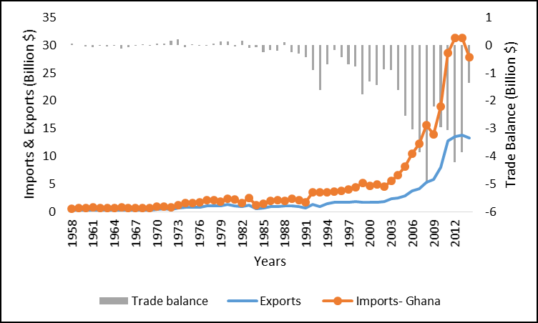

**Figure 5: Trends of Ghana’s trade and trade balance (1958-2014)**

*Source; UNCTADSTAT, 2014 and Author’s own computation*

Generally, the country had been reporting a trade deficit. Between 1958 and 1990, the deficit or surplus was less significant, indicating some kind of balance between the extent to which the country was importing, and the extent of exporting. The quantity of imports from the world to Ghana increased gradually over the years, and the rate of this increase fluctuated between -20% and 5%. In some years, they increased at a decreasing rate (see UNCTADSTRAT, 2014). Ghana’s imports had been adjusting along with the world’s imports, and are dominated by merchandise imports rather than services. Figure 6 presents the proposition of goods and services to the county’s total imports.

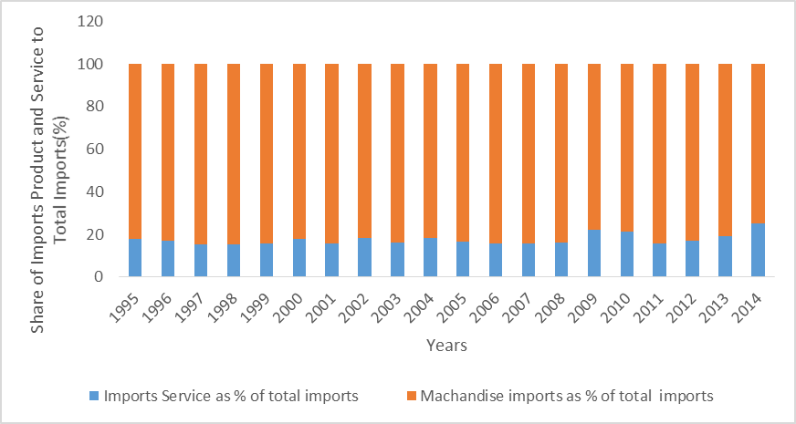

**Figure 6: Ghana’s value of import products and services as a % of total trade (1995-2014)**

Source: *UNCTADSTRAT, 2014*

Import products had been accounting for more than half of Ghana’s imports, while services accounted for less than 25%.

Over the period 1995 to 2014, petroleum, petroleum products and related materials (6.6%), roads vehicle (4.4%), and telecommunication and sound recording apparatus (3.5%) were the major contributors toward the country’s total merchandise imports on annual average. Most of these products, with the exception of petroleum, and petroleum products and related materials, are categorised as manufactured goods (see UNCTADSTRAT, 2014). Manufactured goods have always accounted for more than 50% of goods imported by the country. Figure 7 presents the proportion of major product groups.

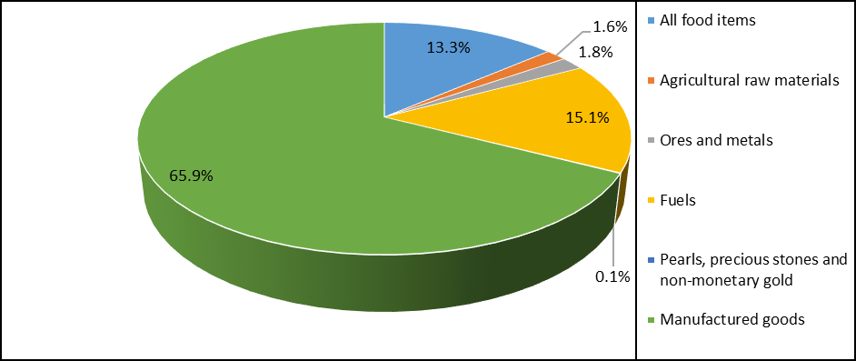

**Figure 7: Average annual composition of Ghana’s imports by major product group (1995-2014)**

*Source; UNCTADSTRAT, 2014 and Author’s own computation*

Ghana’s merchandise imports are dominated by manufactured goods, which accounted for an annual average of 65% over the reported period, followed by fuel (17%), and all food items (6%). The rate at which the manufactured goods component had been growing follows a similar trend as total import products growth (see UNCTADSTRAT, 2014).This could imply that an adjustment in import demand for manufactured goods leads to a related adjustment in the demand for total merchandise imports.

In terms of import services, transport services account for an average of 44% of the total services imports, followed by other services, with the exception of travel services as it accounts for 15% of the total services imports. Even though transport services have been contributing towards a large share of Ghana’s service imports, they have been growing slower than the other services over the years (see UNCTADSTRAT, 2014).

Over period 1995 to 2014, petroleum oils, bitumen, materials and crude oils were the major merchandise imports, accounting for 9% of the total merchandise imports from the world to Ghaba (see UNCTADSTRAT, 2014).

The country trades with both developing and developed countries. During the period 1995 to 2002, the Ghana imported most of its import products from developed countries. However, after 2002, the imports from developing countries started increasing, while imports from developed countries began decreasing (see UNCTADSTRAT, 2014).

1. **Factors Affecting Ghana’s Imports Demand**

Findings from previous studies on the demand for imports suggest real exchange rates, trade liberalisation and economic growth as major determinants of the demand for imports (see Sultan, 2011; Parikh, 2014).

1. **Real Effective Exchange Rate**

Movements in exchange rates lead to changes in imports demand. The changes in exchange rates are commonly a result of exchange rate policies. As uncertainty in the exchange rate becomes intensified, importation lowers (Samini.*et.al*, 2012). A number of studies have supported a significant link between exchange rates and imports demand (see Choudhriand Hakura, 2012; Morrison and Labonte, 2013; Nicita 2013).

Also, theory suggests that, a decrease in real exchange rate index leads to a decrease in imports demanded as importing becomes costly. The relationship between the two variables in the case of Ghana is illustrated in Figure 8.

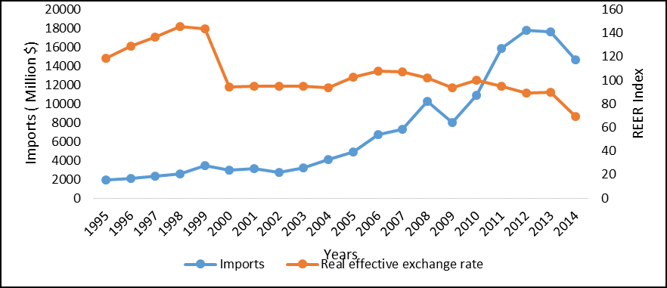

**Figure 8: Real effective exchange rate and imports (1995-2014)**

*Source; UNCTADSTAT, 2014 and Author’s own computation*

Between the year 1995 and 1997 the country experienced a sharp increase in its real effective exchange rate, signifying a loss in the country’s export competitiveness. Following this, imports increased as local goods had become relatively expensive compared with imports. However, this was short-lived as the index decreased by 35% from 143.9 to 94.1 between 1999 and 2000. The country’s real exchange rates index continued to decline by approximately 27% between 2001 and 2014. On the other hand, imports had been increasing and started declining from $17 billion in 2012 to $14 billion in 2014. The continuous increase in imports between 1995 and 2012, regardless of the decline in real effective exchange rate, contradicts theory as the expectation is that imports decrease as importing becomes relatively more expensive over the years. However, the insensitivity of Ghana’s imports is justified by the fact that the country’s imports are dominated by capital goods, which are generally less sensitive to foreign price changes.

1. **Economic Growth**

The linkages between imports and economic growth have been supported by many studies, and economic growth has been identified as one of the major determinants of imports demand (see Mishra, 2012; Aker, 2008). Over the period 2000 to 2014, imports accounted for an average of more than 51% of Ghana’s economic growth (World Bank, 2015). Even though imports play a significant role in growth, their performance still depends on the country’s economic performance, as a rise in real income leads to high consumption (Rivera –Batiz, 1985; cited in Gumede, 2000). Ghana’s imports against the county’s economic growth over the period 1995 to 2012 are presented in Figure 9.

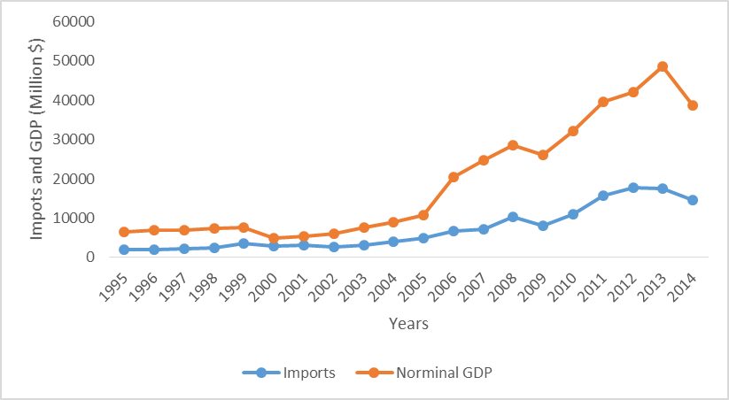

**Figure 9: Trends of Ghana’s imports demand and economic growth (1995-2014)**

*Source; UNCTADSTAT, 2014 and Author’s own computation*

Ghana’s imports demand has corresponded with the country’s economic growth over the period 1995 to 2014. This is not surprising given the significant contribution (85% on average) of trade towards growth (see world bank, 2014).

1. **Trade openness**

The major trade-related adjustments in Ghana have been driven by the process of trade liberalisation. This process encompassed mainly tariff reduction which, hypothetically, encourages imports demand. Figure 10 shows the trends of trade openness against imports demand in Ghana.

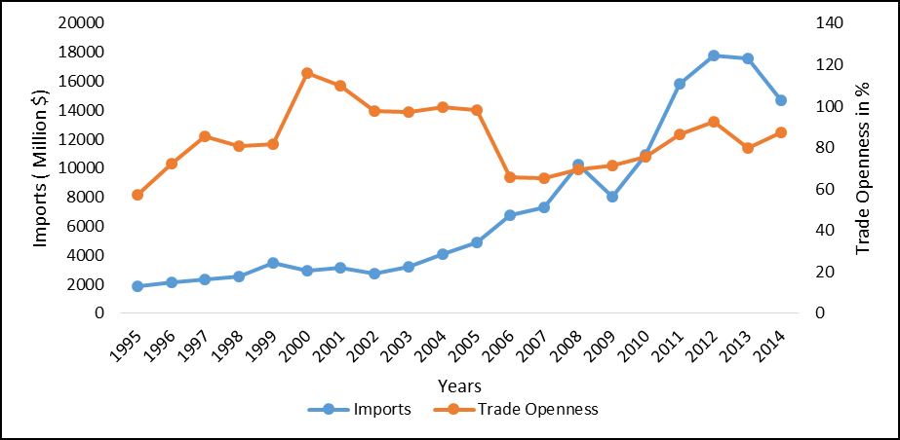

**Figure 10: Trends of trade openness and imports in Ghana (1995-2014)**

*Source; UNCTADSTAT, 2014 and Author’s own computation*

The demand for imports and trade openness in Ghana have not been moving together over the period 1995 to 2014. During the first six years (1995-2000), trends of trade openness show a slow increase in with a few declines in between, and this was followed by a gradual increase in the demand for imports. Between 2001 and 2006, trade openness declined, while imports continued to increase. The decline in trade openness can be attributed to the trade policy adjustment that took place in 2000, which involved increasing tariffs and the re-introduction of special imports tax. After 2006, trade openness started increasing slowly, while, imports started going in the opposite direction.

1. **Conclusion**

This study provides an analysis of the behaviour and structure of Ghana’s imports over the period 1995 to 2014. It also provides a brief analysis of Ghana’s policy developments since its accession to democracy in 1957, focusing on policies affecting Ghana’s import demand. The analysis shows that the country has undergone a number of policy adjustments over the past years. Some of the policy changes were favourable for imports, and some were not. These policy changes were characterised mostly by removal of quantitative restrictions, removal of import tax, reduction of the number of tariff lines, and re-introduction of some of these restrictions. Over this period, the country successfully established a few bilateral trade agreements with African and non-African countries. A larger portion of Ghana’s imports originate from developed countries. The leading import sources for Ghana at a continental level include Europe, Asia, and Africa. In Africa, Nigeria is the main source of Ghana’s imports. Ghana’s imports are dominated by manufactured goods, which account for 65% of the country’s total imports. The import of manufactured goods has been growing faster than the country’s total imports. The study also found that Ghana’s imports demand is sensitive to changes in a number of factors, such as trade openness, economic growth, and the exchange rate.

1. **References**

ActionAid (2013). Analysis of Socio-economic Development and Policy Options under the Interim EPA Regime with the European Union. Ghana under interim economic partnership agreement. Available online; [*http://www.actionaid.org*](http://www.actionaid.org)*.*

Addison, T and Osei, R (2001).Taxation and Fiscal Reform in Ghana. *University of Nations University. Discussion paper.*

Brafu-Insaidoo, W.G. and Obeng, C.K (2008). Effect of Import Liberalization on Tariff Revenue in Ghana. *The African Economic Research Consortium.* *AERC Research Paper 180.*

Bhasin, V.K (2011). Trade Liberalization Financing and its Impact on Poverty and Income Distribution in Ghana. *African Economic Research Consortium, Nairobi. Research paper.*

Choudhri, E. and Hakura, D (2012). The Exchange Rate Pass-Through to Import and Export Prices: The Role of Nominal Rigidities and Currency Choice. *WP/12/226. Washington D. C: IMF.*

Food and Drugs Authority Ghana. 2014. Available online: [*www.fdaghana.gov*](http://www.fdaghana.gov/)

Ghana standards authority (2015). Ghana Product Conformity Assessment Programme. Available online: [*www.gsa.gov*](http://www.gsa.gov/)*.*

Harvey, S and Sedegah, K (2011). Import Demand in Ghana: Structure, Behavior and Stability. *African Economic Research Consortium, Nairobi. AERC Research Paper 233*

<http://data.worldbank.org/>

<http://unctadstat.unctad.org/wds/ReportFolders/reportFolders.aspx>

[*https://ustr.gov/countries-regions/africa/west-africa/ghana*](https://ustr.gov/countries-regions/africa/west-africa/ghana)*.*

Jebuni, C.D, Oduro, A.D. and Tutu, K.A (1994). Trade, Payments, Liberalization and Economic Performance in Ghana. *African Economic Research Consortium, Nairobi. Research Paper 27.*

Laryea, A and Akuoni, S (2012). An Overview of Trade Policies and Developments in Ghana, in Ackah, C and Aryeetey, E (2012). Globalisation, Trade and Poverty in Ghana. *International Development Research Centre PP10-31*. Available online: <http://aercafrica.org/>

Member information -Ghana and the World Trade Organization (2007). Available online: [*https://www.wto.org*](https://www.wto.org/)*.*

Mishra, P.K (2012). The Dynamics of the Relationship between Imports and Economic Growth in India. *South Asian Journal of Macroeconomics and Public Finance 1(1).*

Morrison, W. and Labonte, M (2013). China's Currency Policy: An Analysis of the Economic Issues. *Washington D. C: Congressional Research Service.*

Nicita, A., Ognivtsev, V. and Shirotori, M (2013). Global supply chains: Trade and Economic policies for developing countries. *New York: UN.*

Ocran, M.K., Osei, R.D. and Adjasi, C.K.D (2006). Trade liberalization and Poverty: empirical evidence from household surveys in Ghana. *A paper presented at the CSAE Conference on the Reducing Poverty and Inequality: How can Africa be included? Oxford, U.K.*

Reuben, J, John, C.A and Nozwe, J.N (2013). Theoretical, Analytical, and Methodological Issues on Regional Integration and Bilateral Trade in the ECOWAS Sub-Region: Evidence from Literature on the Gravity Model of Trade. *Journal of Agriculture and Sustainability.3 (2).*

Samimi, A.J. Adibpour. M and Heydarizadeh, N (2012). Exchange Rate Uncertainty and Imports: Evidence from Iran. *Middle-East Journal of Scientific Research 11 (2).*

Steel, W.F (1972). Import Substitution and Excess Capacity in Ghana. *Oxford Economic Papers, New Series, 24 (2).*

Sultan, Z.A (2011). Foreign Exchange Reserves and India’s Import demand: A Cointegration and Vector Error Correction Analysis. *International Journal of Business and Management, 6(7).*

USAID (2006). Trade and Investment Program for a Competitive Export Economy. Annual report for partners October 2005 – September 2006. Available online: [*http://www.usaid.gorv*](http://www.usaid.gorv/) .

World Fact book (2014). [*https://www.cia.gov*](https://www.cia.gov/) .

World Trade Organization (2014). Trade policy review of Ghana. [*https://www.wto.org*](https://www.wto.org/)*.*

[*https://www.quandl.com/data/.../GHA_IS_ROD_TOTL_KM-Ghana-Road*](https://www.quandl.com/data/.../GHA_IS_ROD_TOTL_KM-Ghana-Road)*.*

1.
2.